 | 7.0.1 Editors - 3D Viewport - Object mode - Object Context Menu
Table of content
Detailed table of content 2
Object Context Menu 9
Object Context Menu - All objects 9
Copy Objects 9
Paste Objects 9
Duplicate Objects 10
Rename active Item / Object 10
Mirror sub menu 11
Snap sub menu 12
Parent sub menu 12
Move to Collection 17
Toggle Local View 18
Remove from Local 18
Insert Key frame 18
Insert Key frame with keying sets 18
Delete 18
Show/Hide 19
Mesh object 19
Shade Smooth 19
Shade Auto Smooth 20
Shade Flat 20
Convert to 20
Set Origin 21
Curve object 22
Adjust Extrusion 23
Adjust Offset 23
Shade Smooth 23
Shade Flat 23
Convert to 23
Set Origin 24
Surface object 25
Shade Smooth 25
Shade Flat 25
Convert to 26
Set Origin 27
Metaball object 28
Convert to 28
Set Origin 29
Text object 30
Adjust Extrusion 30
Adjust Offset 30
Convert to 31
Set Origin 32
Volume object 33
Grease Pencil object 33
Convert to 33
Set Origin 34
Armature 35
Set Origin 35
Lattice 36
Set Origin 36
Empty + Image object 37
Adjust Empty Display Size 37
Speaker object 38
Camera object 38
Set Active Camera 38
Adjust Focal Length 38
Adjust Focus Distance 39
Object specific - Light object 39
Point light 39
Sun light 40
Spot light 40
Area light 41
Light Probe object 42
Force Field 42
Adjust Empty Display Size 42
Collection Instance 43
Adjust Empty Display Size 43
Set Origin 43

Detailed table of content

Detailed table of content
Detailed table of content 2
Object Context Menu 9
Object Context Menu - All objects 9
Copy Objects 9
Paste Objects 9
Last Operator Paste Selection from Buffer 9
Select 9
Active Collection 9
Duplicate Objects 10
Last Operator Duplicate 10
Duplicate Objects 10
Linked 10
Move X , Y , Z 10
Orientation 10
Proportional editing 10
Proportional Falloff 10
Proportional Size 10
Connected 10
Projected(2D) 10
Rename active Item / Object 10
Mirror sub menu 11
Interactive Mirror 11
Usage: 11
X Y Z Global 11
X Y Z Local 11
Last Operator Mirror 11
Orientation 11
Proportional editing 11
Proportional Falloff 11
Proportional Size 11
Connected 11
Projected(2D) 11
Snap sub menu 12
Selection to Cursor 12
Selection to Cursor(Keep Offset) 12
Last operator Snap Selection to Cursor 12
Offset 12
Selection to Active 12
Selection to Grid 12
Cursor to Selected 12
Cursor to World Origin 12
Cursor to Active 12
Cursor to Grid 12
Parent sub menu 12
Object 13
Object ( Keep Transform) 13
Armature Deform 13
With empty Groups 13
With Envelope Weights 13
With automatic Weights 13
Bone 13
Bone Relative 13
Curve Deform 14
Follow Path 14
Path Constraint 15
Lattice Deform 15
Vertex 16
Vertex (Triangle) 16
Make Parent without Inverse 16
Make Parent without Inverse (Keep Transform ) 16
Object (Attach Curves to Surface) 16
Last Operator Make Parent 17
Type 17
Keep Transform 17
Clear Parent 17
Clear and Keep Transformation 17
Clear Parent Inverse 17
Last Operator Clear Parent 17
Move to Collection 17
Last Operator Move to Collection 18
Name 18
Toggle Local View 18
Remove from Local 18
Insert Key frame 18
Insert Key frame with keying sets 18
Delete 18
Show/Hide 19
Show Hidden 19
Hide Selected 19
Last Operator Hide Selected 19
Unselected 19
Hide Unselected 19
Mesh object 19
Shade Smooth 19
Last Operator Shade Smooth 19
Keep Sharp Edges 19
Shade Auto Smooth 20
Last Operator Shade Smooth by angle 20
Auto Smooth 20
Angle 20
Shade Flat 20
Last Operator Shade Smooth 20
Keep Sharp Edges 20
Convert to 20
Mesh 20
Curve 20
Curves 20
Grease Pencil 21
Point Cloud 21
Last Operator Convert to Mesh, Curve, Curves & Point Cloud 21
Target 21
Keep Original 21
Merge UV's 21
Last Operator Convert Grease Pencil 21
Type 21
Bevel Depth 21
Bevel Resolution 21
Normalize Weight 21
Radius Factor 21
Link Stroke 21
Set Origin 21
Geometry to Origin 21
Origin to Geometry 22
Origin to 3D cursor 22
Origin to Center of Mass(Surface) 22
Origin to Center of Mass(Volume) 22
Last Operator Set Origin 22
Type 22
Center 22
Curve object 22
Adjust Extrusion 23
Adjust Offset 23
Shade Smooth 23
Shade Flat 23
Convert to 23
Mesh 23
Curve 23
Curves 23
Grease Pencil 23
Point Cloud 24
Last Operator Convert to Mesh, Curve, Curves & Point Cloud 24
Target 24
Keep Original 24
Merge UV's 24
Last Operator Convert Grease Pencil 24
Type 24
Bevel Depth 24
Bevel Resolution 24
Normalize Weight 24
Radius Factor 24
Link Stroke 24
Set Origin 24
Geometry to Origin 24
Origin to Geometry 25
Origin to 3D cursor 25
Origin to Center of Mass(Surface) 25
Origin to Center of Mass(Volume) 25
Last Operator Set Origin 25
Type 25
Center 25
Surface object 25
Shade Smooth 25
Shade Flat 25
Convert to 26
Mesh 26
Curve 26
Curves 26
Grease Pencil 26
Point Cloud 26
Last Operator Convert to Mesh, Curve, Curves & Point Cloud 26
Target 26
Keep Original 26
Merge UV's 26
Last Operator Convert Grease Pencil 26
Type 26
Bevel Depth 26
Bevel Resolution 26
Normalize Weight 26
Radius Factor 27
Link Stroke 27
Set Origin 27
Geometry to Origin 27
Origin to Geometry 27
Origin to 3D cursor 27
Origin to Center of Mass(Surface) 27
Origin to Center of Mass(Volume) 27
Last Operator Set Origin 27
Type 27
Center 27
Metaball object 28
Convert to 28
Mesh 28
Curve 28
Curves 28
Grease Pencil 28
Point Cloud 28
Last Operator Convert to Mesh, Curve, Curves & Point Cloud 28
Target 28
Keep Original 28
Merge UV's 29
Last Operator Convert Grease Pencil 29
Type 29
Bevel Depth 29
Bevel Resolution 29
Normalize Weight 29
Radius Factor 29
Link Stroke 29
Set Origin 29
Geometry to Origin 29
Origin to Geometry 29
Origin to 3D cursor 29
Origin to Center of Mass(Surface) 29
Origin to Center of Mass(Volume) 29
Last Operator Set Origin 30
Type 30
Center 30
Text object 30
Adjust Extrusion 30
Adjust Offset 30
Convert to 31
Mesh 31
Curve 31
Curves 31
Grease Pencil 31
Point Cloud 31
Last Operator Convert to Mesh, Curve, Curves & Point Cloud 31
Target 31
Keep Original 31
Merge UV's 31
Last Operator Convert Grease Pencil 31
Type 31
Bevel Depth 31
Bevel Resolution 31
Normalize Weight 31
Radius Factor 32
Link Stroke 32
Set Origin 32
Geometry to Origin 32
Origin to Geometry 32
Origin to 3D cursor 32
Origin to Center of Mass(Surface) 32
Origin to Center of Mass(Volume) 32
Last Operator Set Origin 32
Type 32
Center 32
Volume object 33
Grease Pencil object 33
Convert to 33
Mesh 33
Curve 33
Curves 33
Grease Pencil 33
Point Cloud 34
Last Operator Convert to Mesh, Curve, Curves & Point Cloud 34
Target 34
Keep Original 34
Merge UV's 34
Last Operator Convert Grease Pencil 34
Type 34
Bevel Depth 34
Bevel Resolution 34
Normalize Weight 34
Radius Factor 34
Link Stroke 34
Set Origin 34
Geometry to Origin 34
Origin to Geometry 35
Origin to 3D cursor 35
Origin to Center of Mass(Surface) 35
Origin to Center of Mass(Volume) 35
Last Operator Set Origin 35
Type 35
Center 35
Armature 35
Set Origin 35
Geometry to Origin 35
Origin to Geometry 36
Origin to 3D cursor 36
Origin to Center of Mass(Surface) 36
Origin to Center of Mass(Volume) 36
Last Operator Set Origin 36
Type 36
Center 36
Lattice 36
Set Origin 36
Geometry to Origin 36
Origin to Geometry 37
Origin to 3D cursor 37
Origin to Center of Mass(Surface) 37
Origin to Center of Mass(Volume) 37
Last Operator Set Origin 37
Type 37
Center 37
Empty + Image object 37
Adjust Empty Display Size 37
Speaker object 38
Camera object 38
Set Active Camera 38
Adjust Focal Length 38
Adjust Focus Distance 39
Object specific - Light object 39
Point light 39
Adjust Light Power 39
Adjust Light Radius 39
Sun light 40
Adjust Light Power 40
Adjust Sun Light Angle 40
Interactive Light Track 40
Spot light 40
Adjust Light Power 41
Adjust Light Radius 41
Adjust Spot Light Size 41
Adjust Spot Light Blend 41
Interactive Light Track 41
Area light 41
Adjust Light Power 41
Adjust Area Light Size 41
Interactive Light Track 42
Light Probe object 42
Force Field 42
Adjust Empty Display Size 42
Collection Instance 43
Adjust Empty Display Size 43
Set Origin 43
Geometry to Origin 43
Origin to Geometry 43
Origin to 3D cursor 43
Origin to Center of Mass(Surface) 43
Origin to Center of Mass(Volume) 43
Last Operator Set Origin 43
Type 44
Center 44

Object Context Menu
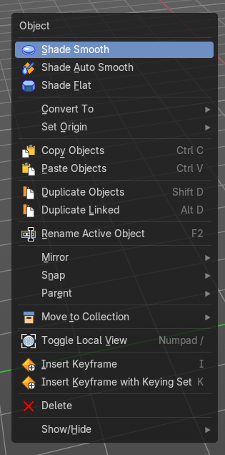
Call this menu with double right click in the 3D viewport. You need to be in Object mode.
The Object Context Menu appears in object mode with all object types. Even without any object in the scene.
The content of this menu differs. With a mesh object you have for example smoothing available too. And with a curve object the convert options.

Object Context Menu - All objects
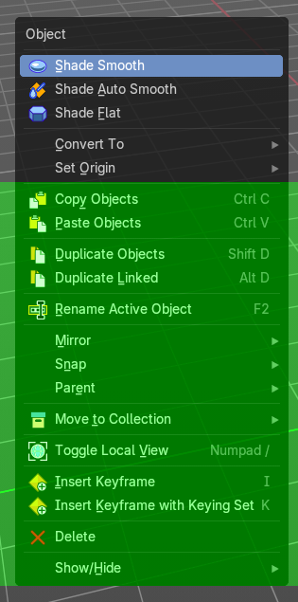
This content shows with all object types.

Copy Objects
Copies the selected object(s).

Paste Objects
Pastes copied object(s).

Last Operator Paste Selection from Buffer

Select
Select pasted object(s).

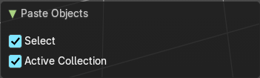
Active Collection
Put the pasted objects into the active collection.

Duplicate Objects
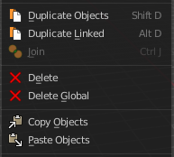
Duplicates selected objects. The copy is completely independent. All containing data gets duplicated too. And you can edit the object instances completely independent. then.
You are automatically in grab mode, and so you can easily move the object out of position. Which is sometimes wanted, since you can position the duplicate then. But sometimes this is unwanted. A right click after releasing the mouse lets the object snap back into its creation position.
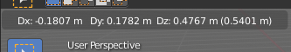
When you drag the duplicate around you will see the position values in the header.

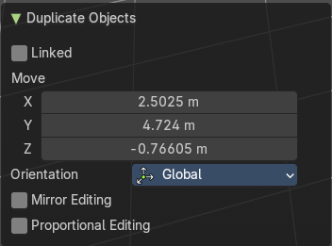
Last Operator Duplicate

Duplicate Objects

Linked
With this option ticked the duplication happens with linked data.

Move X , Y , Z
The Position of the duplicated object.

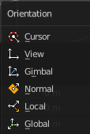
Orientation
Orientation is a drop-down box choose the type of orientation for the duplicate action.

Proportional editing

Enables proportional editing. Activating proportional editing reveals further settings.

Proportional Falloff
Adjust the falloff methods.

Proportional Size
See and adjust the falloff radius.

Connected
The proportional falloff gets calculated for connected parts only.

Projected(2D)
The proportional falloff gets calculated in the screen space. Depth doesn't play a role. When it's in the radius, then it gets calculated.

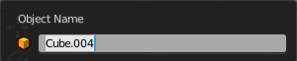
Rename active Item / Object
Allows you to rename the currently active item or object. A rename dialog will pop up where you can type in a new name for the current item. You can have more than one item selected. Just the active item gets renamed.
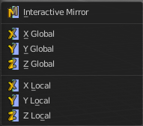

Mirror sub menu
Mirrors the selection.

Interactive Mirror
Mirrors the selection.

Usage:
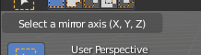
Activate the tool. In the header you will now see further instructions. Which is: type in the axis at which you want to mirror. Interactive mirroring starts in Global space. You can change the orientation in the last operator.

X Y Z Global
Mirrors along the global axis.

X Y Z Local
Mirrors along the object axis.

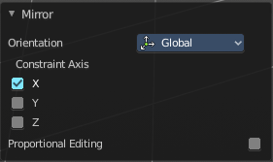

Last Operator Mirror

Orientation
Choose the orientation in which the transform should happen.

Proportional editing
Enables proportional editing. Activating proportional editing reveals further settings.

Proportional Falloff
Adjust the falloff methods.

Proportional Size
See and adjust the falloff radius.

Connected
The proportional falloff gets calculated for connected parts only.

Projected(2D)
The proportional falloff gets calculated in the screen space. Depth doesn't play a role. When it's in the radius, then it gets calculated.

Snap sub menu

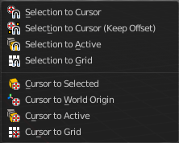
Selection to Cursor
Snaps the currently selected object(s) to the cursor location.

Selection to Cursor(Keep Offset)
Snaps the currently selected object(s) to the cursor location, but keeps the offset of the selected objects to each other. Means the center of the current selection goes to cursor position. Not every individual object.

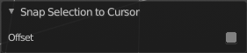
Last operator Snap Selection to Cursor

Offset
Keep the offset of the selected objects to each other.

Selection to Active
Snaps the currently selected object(s) to the active object.

Selection to Grid
Snaps the currently selected object(s) to the nearest grid point.

Cursor to Selected
Moves the cursor to the center of the selected object(s).

Cursor to World Origin
Moves the cursor to the world origin.

Cursor to Active
Moves the cursor to the center of the active object.

Cursor to Grid
Moves the cursor to the nearest grid point.

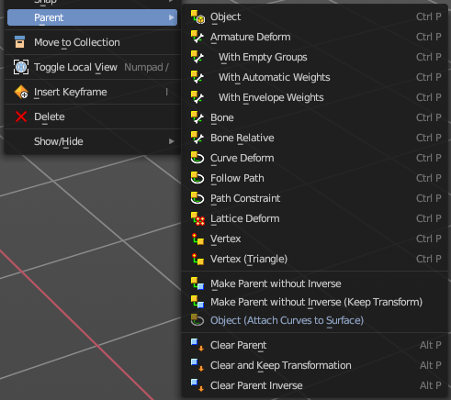
Parent sub menu
The parent menu provides you with all parenting methods at object level.
To use parenting you first have to select the source object, hold down shift, then select the target object so that both are selected. This also works in the outliner (here you can also simply hold down shift and drag the source object at the target object to make it a child). The source object becomes the child object then.

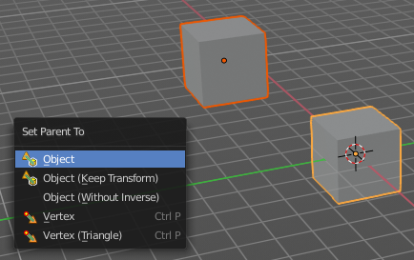
The methods are object type dependent. The armature methods requires to have a mesh and an armature. The path methods a curve. The available methods for the current selection can also be found out by pressing the hotkey ctrl P. This calls the parenting menu with just the available methods.

Object
Sets the parent to selected object.

Object ( Keep Transform)
Sets the parent to selected object, but applies all transform before the operation.

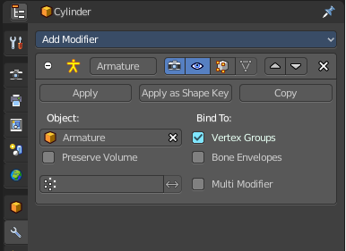
Armature parenting creates an armature modifier at the mesh.

Armature Deform
Sets the parent to selected Armature.

With empty Groups
Sets the parent to selected Armature, using empty groups.

With Envelope Weights
Sets the parent to selected Armature, using envelope weights

With automatic Weights
Sets the parent to selected Armature, with automatic weights.

Bone
Sets the parent absolute to selected Bone.

Bone Relative
Sets the parent relative to selected Bone.

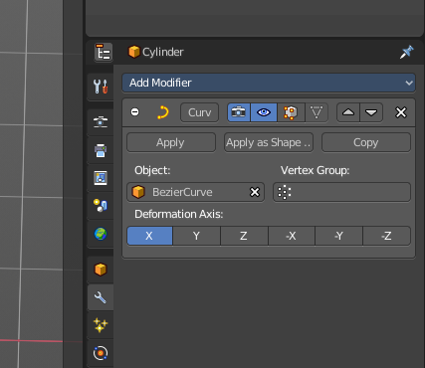
Curve Deform
allows you to deform a mesh by a curve shape. It adds a curve modifier at the mesh.
Usage:
Create a curve. Bend it in edit mode to your needs. Create a mesh. I have for demonstration purposes created a cylinder with several subdivisions.
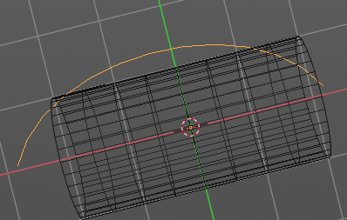

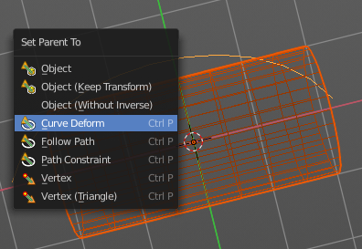
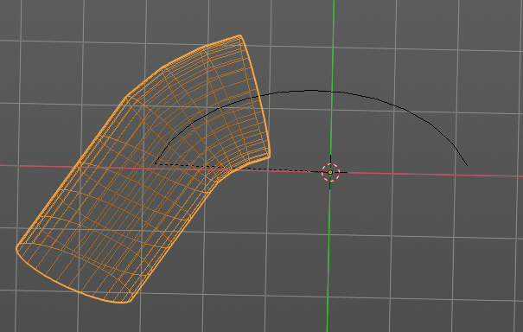

To demonstrate the only pitfall, by parenting the center of the object goes to the start point of the curve. So you better put the origin at the bottom of the cylinder before parenting.

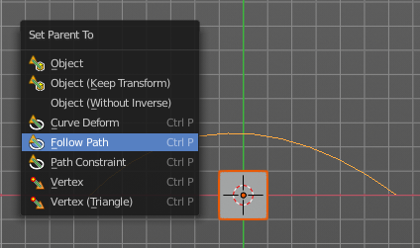
Follow Path
Attaches an object to a curve. The curve then gets used to animate the object position. Every vertice of the curve is one key frame.
Create a curve, create an object, hold down shift and select the curve, make parent ...
Take care of the position and rotation of the object before parenting it to the curve. It influences how the object behaves.
There is a constraint with the same name and functionality. But parenting with follow path will not create such a constraint.

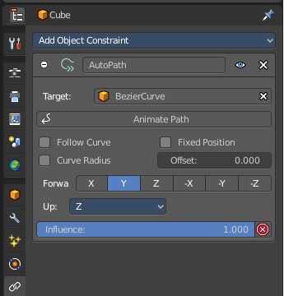
Path Constraint
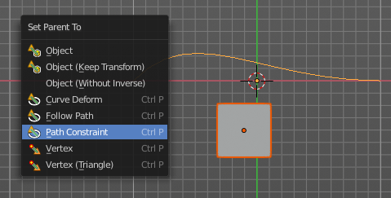
Path constraint adds a AutoPath constraint at the mesh object, which is most probably a wrong labeled path constraint. It is not documented by the Blender developers.

Create a curve, create an object, hold down shift and select the curve, make parent ...
Take care of the position and rotation of the object before parenting it to the curve. It influences how the object behaves.

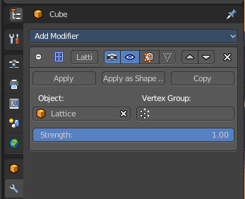
Lattice Deform
Parents a lattice object to the object.
You need a lattice object and a mesh object. Lattice deformations just works with mesh objects.
Create a lattice, create an object, hold down shift and select the lattice, make parent ...
Parent the mesh object to the lattice object with method Lattice Deform. A Lattice Deform constraint will be added at the mesh object.
Take care of the position and size of the lattice object. It influences how the deformation works.
Enter Edit Mode with the lattice object. Deform it. The mesh object will follow the deformation.
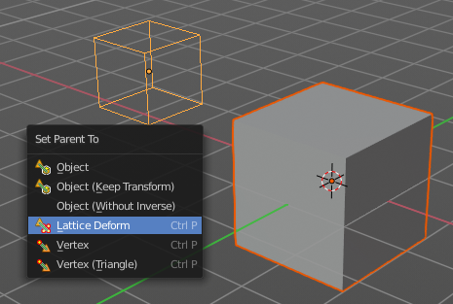
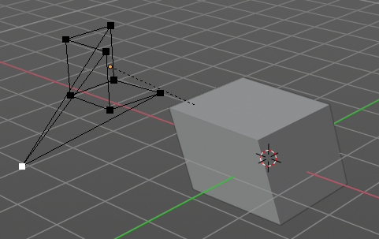

Vertex
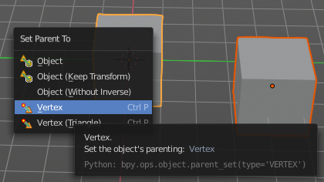
Vertex parents the current object to a vertex of the target object. The vertex will be chosen automatically, it's the
closest vertice of the parent object. When you want to assign the object to a specific vertice, then you have to do
The vertex parenting in Edit mode. You need to have an object type that has vertices. Mesh or curve.
Create a mesh or curve object, create an object, hold down shift and select the mesh object, make parent ...

Vertex (Triangle)
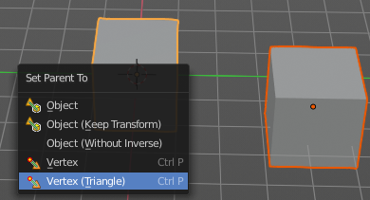
Vertex (Triangle) parents the current object to a face of the target object. The face will be chosen automatically.
It's the closest face of the parent object. When you want to assign the object to a specific face, then you have to
Do the vertex parenting in Edit mode. You need to have an object type that has vertices. Mesh or curve.
Create a mesh or curve object, create an object, hold down shift and select the mesh object, make parent ...

Make Parent without Inverse
With normal parenting the child object keeps its world transformation.
Without inverse parenting the child object uses the coordinate system of the parent object. As one of the effects you will see that the child objects will jump to the origin of the parent object when parenting.

Make Parent without Inverse (Keep Transform )
Set the object’s parenting without setting the inverse parent connections and applies all transform before the operation. Without inverse parenting the child object uses the coordinate system of the parent object. By keeping the transform, the origin of the parent and child object stay in position.

Object (Attach Curves to Surface)
Parent a Hair Curve to the surface of a new object.

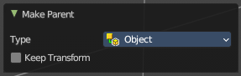
Last Operator Make Parent

Type
Choose the make parent method again. This last operator counts for most of the parent actions.

Keep Transform
Apply transform before parenting.

Clear Parent
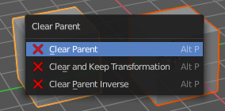
Clear Parent clears the parent relation completely, including involved modifiers.

Clear and Keep Transformation
Clear Parent clears the parent relation completely, including involved modifiers.
But keeps the current visual transformation.

Clear Parent Inverse
Clear Parent Inverse resets the transform corrections applied to the parenting relationship. It does not remove
the parenting itself.

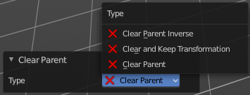
Last Operator Clear Parent
Change the type of clearing.

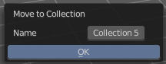
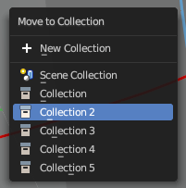
Move to Collection
Moves the selected object to a collection. The object is removed from the collection it was in.
By clicking at this menu item a popup will appear choose the new collection. Allows also to create a new collection. Once done, the object will be moved to this new created collection.
This operator can also be found in the Header Object menu.

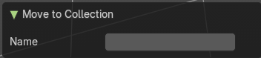
Last Operator Move to Collection

Name
Set a name for your new collection. When you haven't created a new collection, then this name stays blank.

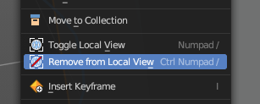
Toggle Local View
Toggles local view isolating the selection in the viewport. You can find this operator in the Header View menu.

Remove from Local
Removes the selection from the Local View keeping the unselected items in the viewport.
You can find this operator in the Header View menu.
Note: This is a conditional operator that only shows when the context of the 3D View editor is in the Local View mode.

Insert Key frame
Inserts a key frame. It uses the default keying set that is defined in the Preferences.

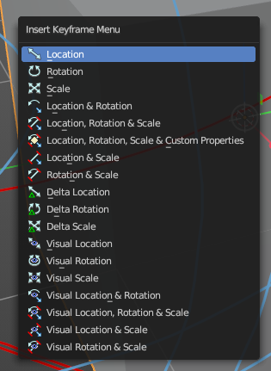
Insert Key frame with keying sets
Calls the Insert Key frame menu where you can choose the keying set that you want to use.
The keying set defines what kind of key frames gets recorded. When you start with an
animation, and your object does not have a keying set yet, then you will be prompted with a menu choose the proper keying set. The Insert Key frame menu.
Note that this just adds a keying set to the current key frame. And not to the whole object. That's why the keying set menu down right stays empty when you add a key frame. this way.

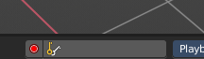

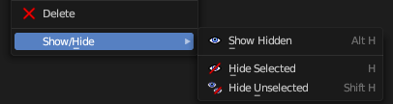
Delete
Deletes the selected object(s).

Show/Hide
Sub-menu with shows or hide selection, unselected or hidden operators.

Show Hidden
Makes all geometry in the scene visible again.

Hide Selected
Hides the selected geometry.


Last Operator Hide Selected

Unselected
Hides the not selected geometry.

Hide Unselected
Hides the not selected geometry. The selected geometry stays visible.

Mesh object
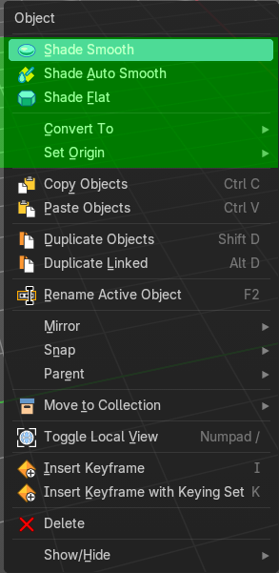

Shade Smooth
Sets the shading for the object to smooth. Smooth means that the sharp edges are no longer seen.
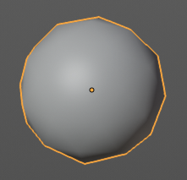


Last Operator Shade Smooth

Keep Sharp Edges
Don't remove as sharp marked edges.

Shade Auto Smooth
Sets the shading for the object to smooth with Autosmooth activated. Autosmooth means that sharp edges above an angle threshold will have sharp faceted faces, meanwhile angles under the threshold will be smooth.

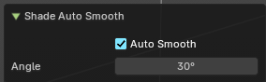
Last Operator Shade Smooth by angle

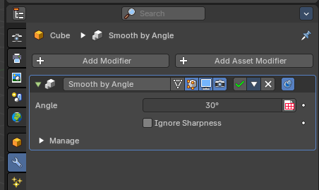
Auto Smooth
Creates a auto smooth modifier for auto smoothing in the modifier stack. Where you can adjust the settings at any further step. Else it applies the current auto smooth to the mesh normals.

Angle
Maximum angle between face normals that will be considered as smooth.

Shade Flat
Sets the shading for the object to flat. Flat means that every face of the object shows faceted, with a sharp edge.
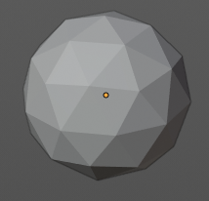

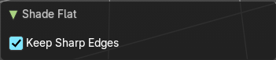
Last Operator Shade Smooth

Keep Sharp Edges
Don't remove as sharp marked edges.

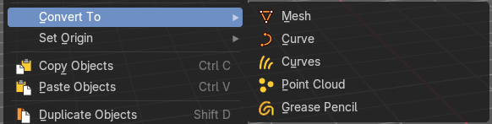
Convert to

Mesh
Converts a selected object to a Mesh Object.

Curve
Converts a selected Mesh or Text Object to a Curve Object.

Curves
Converts a selected Mesh or Text Object to a Hair Curves Object.

Grease Pencil
Converts a selected curve to a grease pencil stroke.

Point Cloud
Converts a selected object to a point cloud object.

Last Operator Convert to Mesh, Curve, Curves & Point Cloud

Target
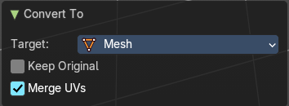
Target is a drop-down box that allows you to choose the convert method again.

Keep Original
With this option ticked the original object gets kept. And a new object gets created.

Merge UV's
Merge UV coordinates that shares a vertex.

Last Operator Convert Grease Pencil

Type
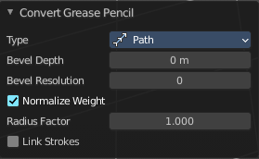
Type is a drop-down box that allows you to choose the convert method again.

Bevel Depth
A curve can have a extruded geometry with bevel. Adjust the bevel depth.

Bevel Resolution
A curve can have a extruded geometry with bevel. Adjust the bevel resolution.

Normalize Weight
Normalize the weight, set from stroke width.

Radius Factor
Multiplier for the points radii, set from stroke width.

Link Stroke

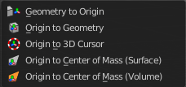
Set Origin

Geometry to Origin
Sets the geometry to origin.

Origin to Geometry
Sets the origin to geometry.

Origin to 3D cursor
Sets the origin to the 3D cursor.

Origin to Center of Mass(Surface)
Sets the origin to the center of mass, calculating it from the center of the surface area.

Origin to Center of Mass(Volume)
Sets the origin to the center of mass, calculating from the center of the Volume. It must be manifold geometry with consistent normal's.

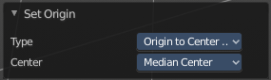
Last Operator Set Origin
The last operator is the same for all set origin methods.

Type
Choose the method again.

Center
Use the median center or the bounds center for calculation.

Curve object

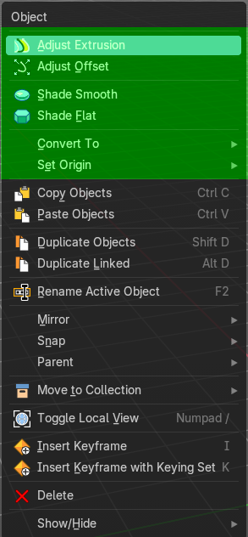

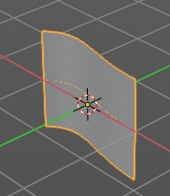
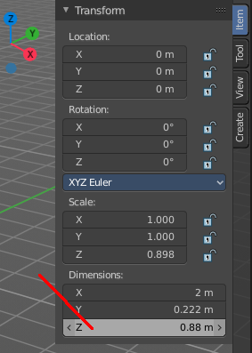
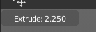
Adjust Extrusion
Extrudes a surface out of a curve or text object.

In the header you can see the height of the extrusion. In the Transform panel in the sidebar you can adjust this height also afterwards. The Z value.

Adjust Offset
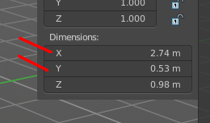
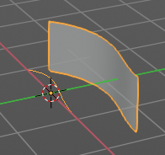

Adjust Offset is just of interest when you have an extruded surface at the curve. It scales the surface size in x and z direction.

Shade Smooth
Sets the shading for the object to smooth. Smooth means that the sharp edges are no longer seen.

Shade Flat
Sets the shading for the object to flat. Flat means that every face of the object shows faceted, with a sharp edge.

Convert to

Mesh
Converts a selected object to a Mesh Object.

Curve
Converts a selected Mesh or Text Object to a Curve Object.

Curves
Converts a selected Mesh or Text Object to a Hair Curves Object.

Grease Pencil
Converts a selected curve to a grease pencil stroke.

Point Cloud
Converts a selected object to a point cloud object.

Last Operator Convert to Mesh, Curve, Curves & Point Cloud

Target
Target is a drop-down box that allows you to choose the convert method again.

Keep Original
With this option ticked the original object gets kept. And a new object gets created.

Merge UV's
Merge UV coordinates that shares a vertex.

Last Operator Convert Grease Pencil

Type
Type is a drop-down box that allows you to choose the convert method again.

Bevel Depth
A curve can have a extruded geometry with bevel. Adjust the bevel depth.

Bevel Resolution
A curve can have a extruded geometry with bevel. Adjust the bevel resolution.

Normalize Weight
Normalize the weight, set from stroke width.

Radius Factor
Multiplier for the points radii, set from stroke width.

Link Stroke

Set Origin

Geometry to Origin
Sets the geometry to origin.

Origin to Geometry
Sets the origin to geometry.

Origin to 3D cursor
Sets the origin to the 3D cursor.

Origin to Center of Mass(Surface)
Sets the origin to the center of mass, calculating it from the center of the surface area.

Origin to Center of Mass(Volume)
Sets the origin to the center of mass, calculating from the center of the Volume. It must be manifold geometry with consistent normal's.

Last Operator Set Origin
The last operator is the same for all set origin methods.

Type
Choose the method again.

Center
Use the median center or the bounds center for calculation.

Surface object

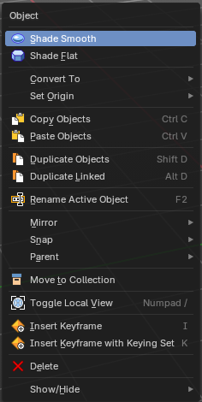
Shade Smooth
Sets the shading for the object to smooth. Smooth means that the sharp edges are no longer seen.

Shade Flat
Sets the shading for the object to flat. Flat means that every face of the object shows faceted, with a sharp edge.

Convert to

Mesh
Converts a selected object to a Mesh Object.

Curve
Converts a selected Mesh or Text Object to a Curve Object.

Curves
Converts a selected Mesh or Text Object to a Hair Curves Object.

Grease Pencil
Converts a selected curve to a grease pencil stroke.

Point Cloud
Converts a selected object to a point cloud object.

Last Operator Convert to Mesh, Curve, Curves & Point Cloud

Target
Target is a drop-down box that allows you to choose the convert method again.

Keep Original
With this option ticked the original object gets kept. And a new object gets created.

Merge UV's
Merge UV coordinates that shares a vertex.

Last Operator Convert Grease Pencil

Type
Type is a drop-down box that allows you to choose the convert method again.

Bevel Depth
A curve can have a extruded geometry with bevel. Adjust the bevel depth.

Bevel Resolution
A curve can have a extruded geometry with bevel. Adjust the bevel resolution.

Normalize Weight
Normalize the weight, set from stroke width.

Radius Factor
Multiplier for the points radii, set from stroke width.

Link Stroke

Set Origin

Geometry to Origin
Sets the geometry to origin.

Origin to Geometry
Sets the origin to geometry.

Origin to 3D cursor
Sets the origin to the 3D cursor.

Origin to Center of Mass(Surface)
Sets the origin to the center of mass, calculating it from the center of the surface area.

Origin to Center of Mass(Volume)
Sets the origin to the center of mass, calculating from the center of the Volume. It must be manifold geometry with consistent normal's.

Last Operator Set Origin
The last operator is the same for all set origin methods.

Type
Choose the method again.

Center
Use the median center or the bounds center for calculation.

Metaball object

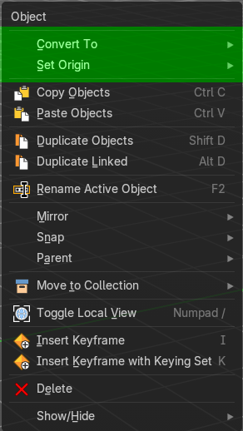

Convert to

Mesh
Converts a selected object to a Mesh Object.

Curve
Converts a selected Mesh or Text Object to a Curve Object.

Curves
Converts a selected Mesh or Text Object to a Hair Curves Object.

Grease Pencil
Converts a selected curve to a grease pencil stroke.

Point Cloud
Converts a selected object to a point cloud object.

Last Operator Convert to Mesh, Curve, Curves & Point Cloud

Target
Target is a drop-down box that allows you to choose the convert method again.

Keep Original
With this option ticked the original object gets kept. And a new object gets created.

Merge UV's
Merge UV coordinates that shares a vertex.

Last Operator Convert Grease Pencil

Type
Type is a drop-down box that allows you to choose the convert method again.

Bevel Depth
A curve can have a extruded geometry with bevel. Adjust the bevel depth.

Bevel Resolution
A curve can have a extruded geometry with bevel. Adjust the bevel resolution.

Normalize Weight
Normalize the weight, set from stroke width.

Radius Factor
Multiplier for the points radii, set from stroke width.

Link Stroke
Link strokes with zero radius sections of curves.

Set Origin

Geometry to Origin
Sets the geometry to origin.

Origin to Geometry
Sets the origin to geometry.

Origin to 3D cursor
Sets the origin to the 3D cursor.

Origin to Center of Mass(Surface)
Sets the origin to the center of mass, calculating it from the center of the surface area.

Origin to Center of Mass(Volume)
Sets the origin to the center of mass, calculating from the center of the Volume. It must be manifold geometry with consistent normal's.

Last Operator Set Origin
The last operator is the same for all set origin methods.

Type
Choose the method again.

Center
Use the median center or the bounds center for calculation.

Text object

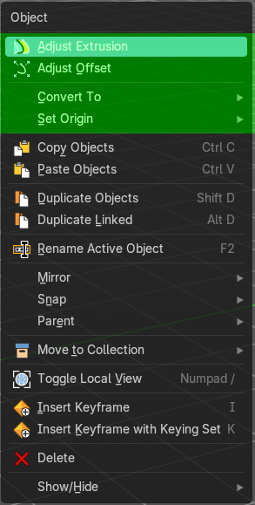

Adjust Extrusion
Extrudes a surface out of a curve or text object.
In the header you can see the height of the extrusion. In the Transform panel in the sidebar you can adjust this height also afterwards. The Z value.

Adjust Offset
Width size is just of interest when you have an extruded surface at the curve. It scales the surface size in x and z direction.

Convert to

Mesh
Converts a selected object to a Mesh Object.

Curve
Converts a selected Mesh or Text Object to a Curve Object.

Curves
Converts a selected Mesh or Text Object to a Hair Curves Object.

Grease Pencil
Converts a selected curve to a grease pencil stroke.

Point Cloud
Converts a selected object to a point cloud object.

Last Operator Convert to Mesh, Curve, Curves & Point Cloud

Target
Target is a drop-down box that allows you to choose the convert method again.

Keep Original
With this option ticked the original object gets kept. And a new object gets created.

Merge UV's
Merge UV coordinates that shares a vertex.

Last Operator Convert Grease Pencil

Type
Type is a drop-down box that allows you to choose the convert method again.

Bevel Depth
A curve can have a extruded geometry with bevel. Adjust the bevel depth.

Bevel Resolution
A curve can have a extruded geometry with bevel. Adjust the bevel resolution.

Normalize Weight
Normalize the weight, set from stroke width.

Radius Factor
Multiplier for the points radii, set from stroke width.

Link Stroke
Link strokes with zero radius sections of curves.

Set Origin

Geometry to Origin
Sets the geometry to origin.

Origin to Geometry
Sets the origin to geometry.

Origin to 3D cursor
Sets the origin to the 3D cursor.

Origin to Center of Mass(Surface)
Sets the origin to the center of mass, calculating it from the center of the surface area.

Origin to Center of Mass(Volume)
Sets the origin to the center of mass, calculating from the center of the Volume. It must be manifold geometry with consistent normal's.

Last Operator Set Origin
The last operator is the same for all set origin methods.

Type
Choose the method again.

Center
Use the median center or the bounds center for calculation.

Volume object
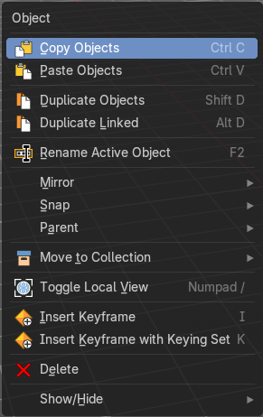
Just default settings.

Grease Pencil object
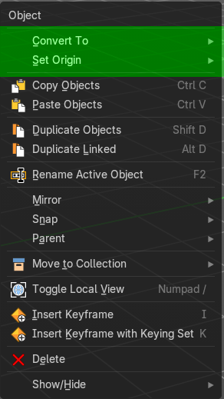

Convert to

Mesh
Converts a selected object to a Mesh Object.

Curve
Converts a selected Mesh or Text Object to a Curve Object.

Curves
Converts a selected Mesh or Text Object to a Hair Curves Object.

Grease Pencil
Converts a selected curve to a grease pencil stroke.

Point Cloud
Converts a selected object to a point cloud object.

Last Operator Convert to Mesh, Curve, Curves & Point Cloud

Target
Target is a drop-down box that allows you to choose the convert method again.

Keep Original
With this option ticked the original object gets kept. And a new object gets created.

Merge UV's
Merge UV coordinates that shares a vertex.

Last Operator Convert Grease Pencil

Type
Type is a drop-down box that allows you to choose the convert method again.

Bevel Depth
A curve can have a extruded geometry with bevel. Adjust the bevel depth.

Bevel Resolution
A curve can have a extruded geometry with bevel. Adjust the bevel resolution.

Normalize Weight
Normalize the weight, set from stroke width.

Radius Factor
Multiplier for the points radii, set from stroke width.

Link Stroke
Link strokes with zero radius sections of curves.

Set Origin

Geometry to Origin
Sets the geometry to origin.

Origin to Geometry
Sets the origin to geometry.

Origin to 3D cursor
Sets the origin to the 3D cursor.

Origin to Center of Mass(Surface)
Sets the origin to the center of mass, calculating it from the center of the surface area.

Origin to Center of Mass(Volume)
Sets the origin to the center of mass, calculating from the center of the Volume. It must be manifold geometry with consistent normal's.

Last Operator Set Origin
The last operator is the same for all set origin methods.

Type
Choose the method again.

Center
Use the median center or the bounds center for calculation.

Armature

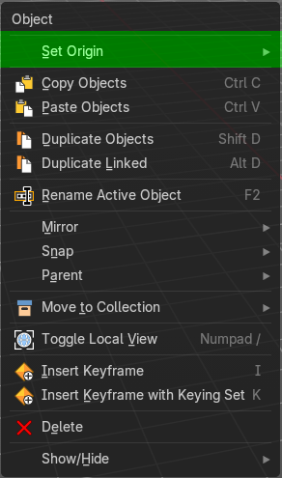

Set Origin

Geometry to Origin
Sets the geometry to origin.

Origin to Geometry
Sets the origin to geometry.

Origin to 3D cursor
Sets the origin to the 3D cursor.

Origin to Center of Mass(Surface)
Sets the origin to the center of mass, calculating it from the center of the surface area.

Origin to Center of Mass(Volume)
Sets the origin to the center of mass, calculating from the center of the Volume. It must be manifold geometry with consistent normal's.

Last Operator Set Origin
The last operator is the same for all set origin methods.

Type
Choose the method again.

Center
Use the median center or the bounds center for calculation.

Lattice
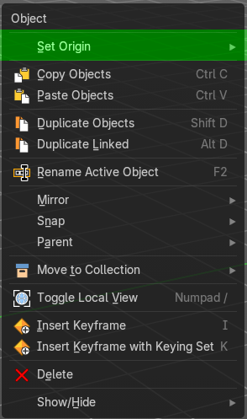

Set Origin

Geometry to Origin
Sets the geometry to origin.

Origin to Geometry
Sets the origin to geometry.

Origin to 3D cursor
Sets the origin to the 3D cursor.

Origin to Center of Mass(Surface)
Sets the origin to the center of mass, calculating it from the center of the surface area.

Origin to Center of Mass(Volume)
Sets the origin to the center of mass, calculating from the center of the Volume. It must be manifold geometry with consistent normal's.

Last Operator Set Origin
The last operator is the same for all set origin methods.

Type
Choose the method again.

Center
Use the median center or the bounds center for calculation.

Empty + Image object
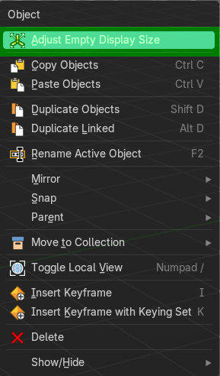
The Image object types is a special kind of an empty. So they have the same entry in the context menu.

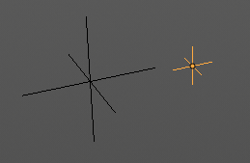
Adjust Empty Display Size
Scale the size of the empty in the viewport.
Note, this value does not show elsewhere. And there is no way to reset it to the default size except to scale it again with Empty Draw Size. The value in the header will help you.

Speaker object
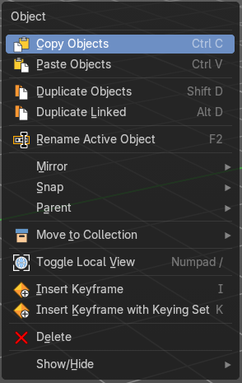
Just default settings.

Camera object
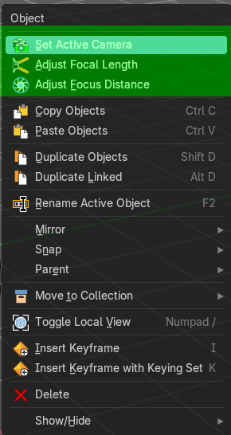

Set Active Camera
Sets the currently selected camera as the active camera, and switches to camera view.

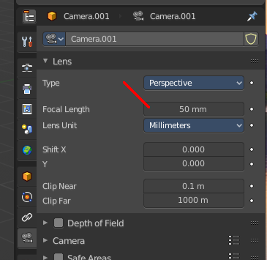
Adjust Focal Length
Changes the focal length of the camera. You can adjust it afterwards in the properties editor.
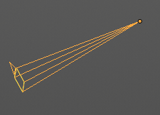

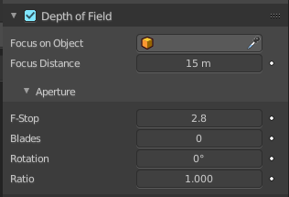
Adjust Focus Distance
Changes the focus distance for depth of field. You can adjust it afterwards in the properties editor. The values in the depth of field are not as exact as the dof distance values though.

Object specific - Light object
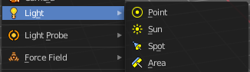
There are four different light types. Each light type has its own settings. Power is the same in all. When you adjust the values then you will see a string with the values in the header.

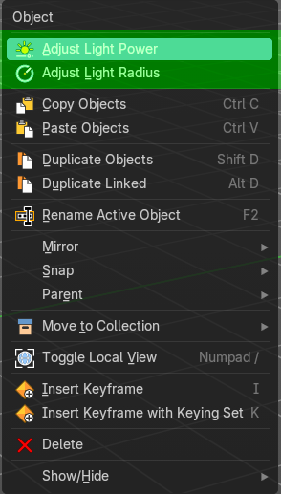
Point light

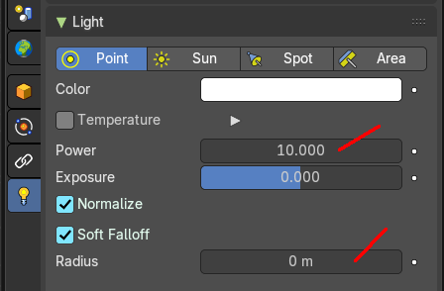
Adjust Light Power
Adjust the power of the light. The light power setting is in the properties editor in the light panel in the object data properties tab.

Adjust Light Radius
Adjust the radius of the point light.

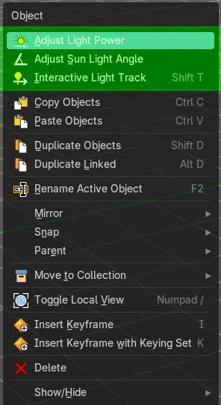
Sun light

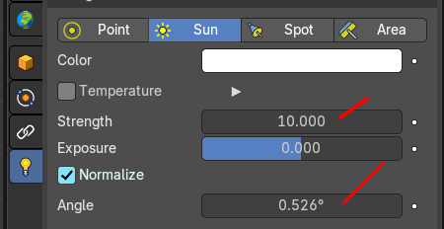
Adjust Light Power
Adjust the power of the light. The light power setting is in the properties editor in the light panel in the object data properties tab.

Adjust Sun Light Angle
Adjust the angle of the sun light.

Interactive Light Track
Navigate a lamp of type sun or spot light to point at objects. The lamp follows the mouse cursor.

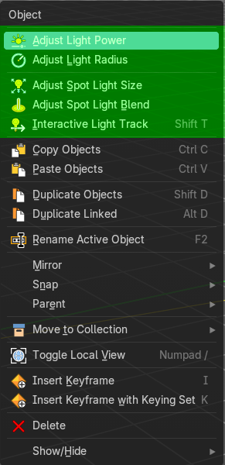
Spot light

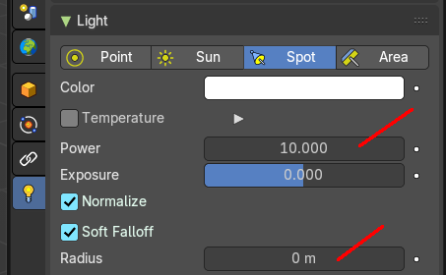
Adjust Light Power
Adjust the power of the light. The light power setting is in the properties editor in the light panel in the object data properties tab.

Adjust Light Radius
Adjust the radius of the light.

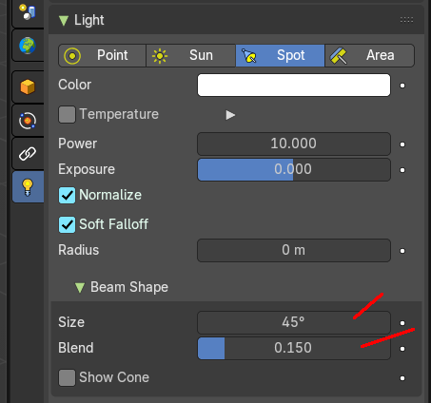
Adjust Spot Light Size
Adjust the angle of the spotlight beam. Note that the value in the header is in radians, while the value in the panel is in degrees.

Adjust Spot Light Blend
Adjust softness of the spotlight edge.

Interactive Light Track
Navigate a lamp of type sun or spot light to point at objects. The lamp follows the mouse cursor.

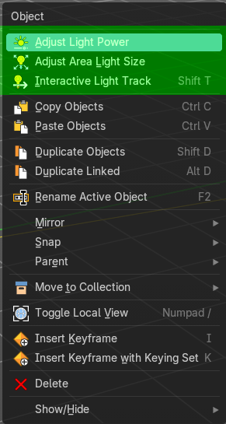
Area light

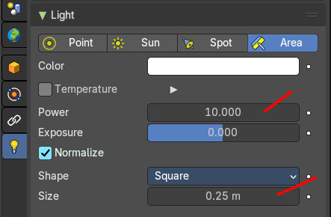
Adjust Light Power
Adjust the power of the light. The light power setting is in the properties editor in the light panel in the object data properties tab.

Adjust Area Light Size
Area light only.
Scale the size of the area light. Size Y appears with Shape Rectangle.

Interactive Light Track
Navigate a lamp of type sun or spot light to point at objects. The lamp follows the mouse cursor.

Light Probe object
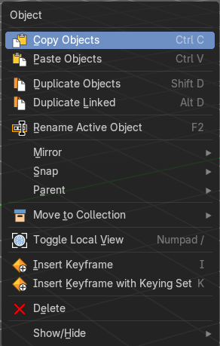
Just default settings.

Force Field
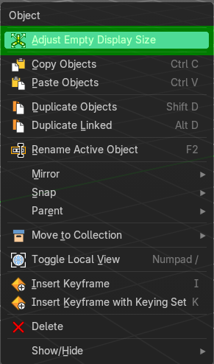
The force field is displayed as an empty.

Adjust Empty Display Size
Scale the size of the empty in the viewport.
Note, this value does not show elsewhere. And there is no way to reset it to the default size except to scale it again with Empty Draw Size. The value in the header will help you.

Collection Instance
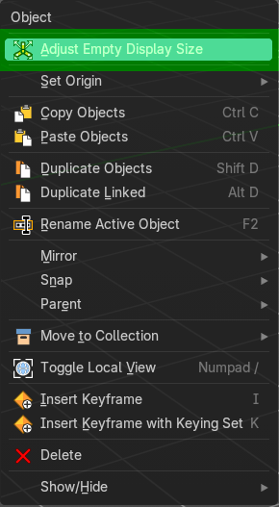

Adjust Empty Display Size
Scale the size of the empty in the viewport.
Note, this value does not show elsewhere. And there is no way to reset it to the default size except to scale it again with Empty Draw Size. The value in the header will help you.

Set Origin

Geometry to Origin
Sets the geometry to origin.

Origin to Geometry
Sets the origin to geometry.

Origin to 3D cursor
Sets the origin to the 3D cursor.

Origin to Center of Mass(Surface)
Sets the origin to the center of mass, calculating it from the center of the surface area.

Origin to Center of Mass(Volume)
Sets the origin to the center of mass, calculating from the center of the Volume. It must be manifold geometry with consistent normal's.

Last Operator Set Origin
The last operator is the same for all set origin methods.

Type
Choose the method again.

Center
Use the median center or the bounds center for calculation.

